Leisure Centre, Gym, and Health Activities
Updated: November 2025

Organisation | NHS Discount Offer | Website Link
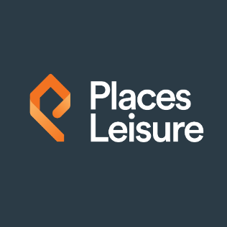  Northumberland | Places Leisure offer NHS staff the opportunity to join their Premium Concessions membership that provides all the benefits of their premium membership but at a discounted rate.  To join you need to go into the leisure centre with your NHS ID or proof you work for the trust within 14 days of joining. The team will then be able to set up your membership.  Please check full T&C’s before organising a membership. | Home - Places Leisure
  Newcastle and Cumbria | Better offers NHS staff 20% off their membership costs with certain centres. Choose a corporate membership when joining online and select NHS from the list of companies. The eligibility check allows you to upload an image of your valid NHS staff card.  Leisure Centres and facilities in Newcastle and North Cumbria areas.  Please check full T&C’s before organising a membership. | https://www.better.org.uk/leisure-centres
Organisation | NHS Discount Offer | Website Link
  Sunderland | NHS discount is classified as a ‘Concession Membership”. It gives you access to all facilities at all the Everyone Active centres.  Upon your first visit to the centre in order to pick up your membership card and begin your fitness journey with them, they ask that you bring some sort of proof that you are eligible for their concession gym membership with you.  Please check full T&C’s before organising a membership. | www.everyoneactive.com
  Gateshead | Gateshead Leisure Centre offers all NHS Staff on presenting of their Blue Light card the opportunity to join their concession prices.  Please check full T&C’s before organising a membership. | Memberships - Leisure Hub
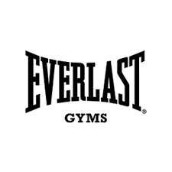  Gateshead, Carlisle, Sunderland | Everlast Gyms located in Gateshead offer NHS Staff access to discount when joining. All you need to do is call your local gym to get signed up today or call in to do this in person. They will need to see your ID in order to verify it before your first workout.  Please check full T&C’s before organising a membership. | https://www.everlastgyms.com/
Organisation | NHS Discount Offer | Website Link
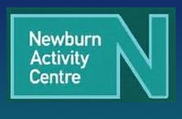  Newcastle | NHS Staff and Uniform Services Gym Discount  Newburn Activity Centre offers a corporate discount of £25.  Call them on 0191 2640014 or pop into the reception and ask at the desk.  Please check full T&C’s before organising a membership. | Home -
 | The Gym Group offers NHS colleagues 10% off their monthly subscription. This can be accessed through Health Service Discounts or even through the Blue Light website.  Gyms in the area include Gosforth, Newcastle City Centre, Heaton, South Shields and Sunderland.  Please check full T&C’s before organising a membership.

Organisation | NHS Discount Offer | Website Link
  South Tyneside | Corporate membership for NHS staff.  Duo Membership – Which consists of two activities unlimited use. (e.g. Gym/ Swim Duo - unlimited use of the pool, sauna, and steam room & unlimited use of the gym)  Multi Membership – Which consists of all three activities unlimited use. (e.g. Gym/Swim/ Classes – Unlimited use of all three).  To be able to get the corporate membership NHS staff must present evidence at a reception desk of NHS employment.  Memberships can be set up online but when collecting the Get Active card you would need to present ID evidence then.  The following centres are included:  - Hebburn Central  - Haven Point  - Monkton Stadium  - Jarrow Focus  - Jarrow Community Pool  Please check full T&C’s before organising a membership. | Leisure centres - South Tyneside Council

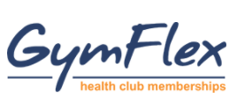 | Gym Flex through the staff benefits portal Vivup offers discounted gym membership to staff. Visit: https://www.vivup.co.uk to find a local gym.

 | Check out Health Service Discounts for the latest Gym Memberships, NHs Discounts and Deals | NHS Gym Discounts | Memberships | Health Service Discounts
 | Check out the Blue Light Card website for the latest Gym Memberships, NHs Discounts and Deals | Sports & Fitness Discounts | Blue Light Card
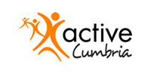 | Offer a range of sporting activities | Activities & Sports - Active Cumbria

